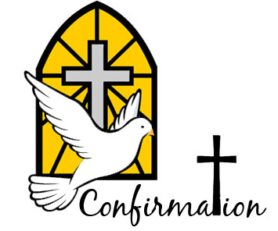
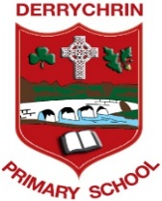
Parish of St. Patrick’s Ballinderry

Sacrament of Confirmation
for
Derrychrin PS and Ballylifford PS

Thursday 4th November 2021
Dear Parents/Guardians,

Following discussions with Rev. Fr Donnelly, both primary schools Derrychrin PS and Ballylifford PS are pleased to inform you of the official date for this year's Sacrament of Confirmation in Ballinderry Parish.

Sacrament of Confirmation for both parish schools will take place on Saturday 30th April 2022.

There will be two separate ceremonies for Derrychrin PS and one ceremony for Ballylifford PS.

Derrychrin PS - Group One at 10am and Group Two at 11:30am
(A list of pupils for each ceremony will be issued separately to parents)

Ballylifford PS at 1pm

With COVID restrictions still in place and to keep everyone as safe as possible, Confirmation celebrations will take the form of separate Mass ceremonies for both schools with reduced numbers present. The ceremonies are private to the families concerned and out of necessity numbers are restricted to households only. This will ensure that the maximum capacity in the church will not be exceeded at each ceremony.

The P7 children will be accompanied into the church only by their parents & siblings - brothers & sisters. Unfortunately, no one else is allowed to attend and one of the parents will act as sponsor. We have been asked that this rule be strictly adhered to by everyone.

Each family will have a pew in which to sit - creating a 'family bubble'. The wearing of face masks is mandatory for adults, in all indoor settings including churches. All adults must wear a face covering during the celebration.

All Confirmation services will be broadcast live on Ballinderry Parish Webcam - no recording shall take place. https://www.churchservices.tv/ballinderry

The Ceremony of Light for our P7 pupils will take place on separate days for both schools. Further information will be issued to parents in due course.

We aim to make this a very special occasion for our P7 children and hope that they all enjoy their big day.

Many thanks

Mr Ciaran McElroy Mrs Fiona Conway
Principal of Derrychrin PS Principal of Ballylifford PS

