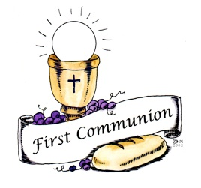
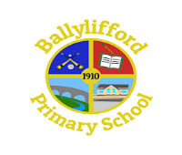
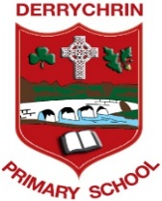
Parish of St. Patrick’s Ballinderry

First Holy Communion
for
Derrychrin PS and Ballylifford PS

Thursday 4th November 2021
Dear Parents/Guardians,

Following discussions with Rev. Fr Donnelly, both primary schools Derrychrin PS and Ballylifford PS are pleased to inform you of the official date for this year's First Holy Communion in Ballinderry Parish.

First Communion for both parish schools will take place on Saturday 14th May 2022.

There will be two separate ceremonies for Derrychrin PS and one ceremony for Ballylifford PS.

Derrychrin PS - Group One at 10am and Group Two at 11:30am
(A list of pupils for each ceremony will be issued separately to parents)

Ballylifford PS at 1pm

With COVID restrictions still in place and to keep everyone as safe as possible, First Holy Communion celebrations will take the form of separate Mass ceremonies for both schools with reduced numbers present. The ceremonies are private to the families concerned and out of necessity numbers are restricted to households only. This will ensure that the maximum capacity in the church will not be exceeded at each ceremony.

First Communion children will be accompanied into the church only by their parents & siblings - brothers & sisters. Unfortunately, no one else is allowed to attend and we have been asked that this rule be strictly adhered to by everyone.

Each family will have a pew in which to sit - creating a 'family bubble'. The wearing of face masks is mandatory for adults, in all indoor settings including churches. All adults must wear a face covering during the celebration.

All First Communion services will be broadcast live on Ballinderry Parish Webcam - no recording shall take place. https://www.churchservices.tv/ballinderry

A Penitential Service will take place prior to the First Communion ceremony in recognition of the children celebrating the Sacrament of Penance.

We aim to make this a very special occasion for our First Communion children and hope that they all enjoy their big day.
Many thanks

Mr Ciaran McElroy Mrs Fiona Conway
Principal of Derrychrin PS Principal of Ballylifford PS

