Exciting News…

Our Friends of Ballylifford have been awarded £9750.00 to create an Eco Space and Community Garden in our school.
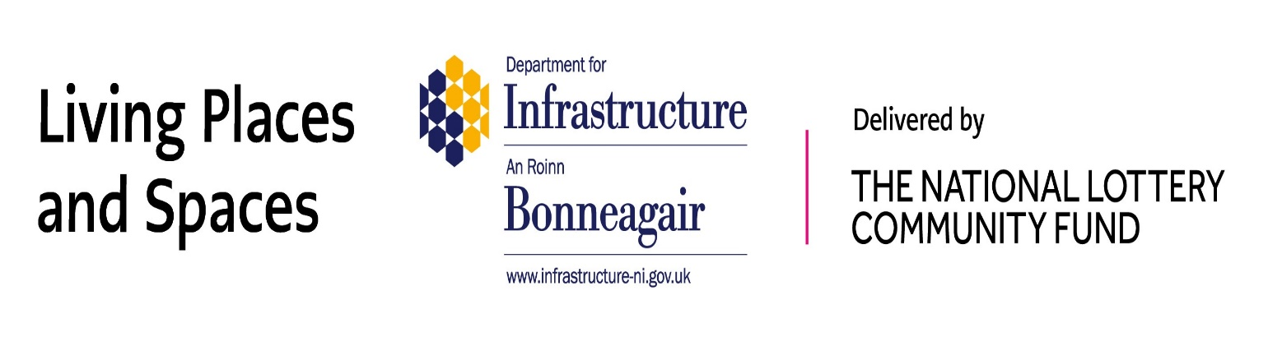
Thank you to the ‘Department of Infrastructure Living Places and Spaces’ for funding our project. Watch this space for more information!

