Ballylifford Primary School

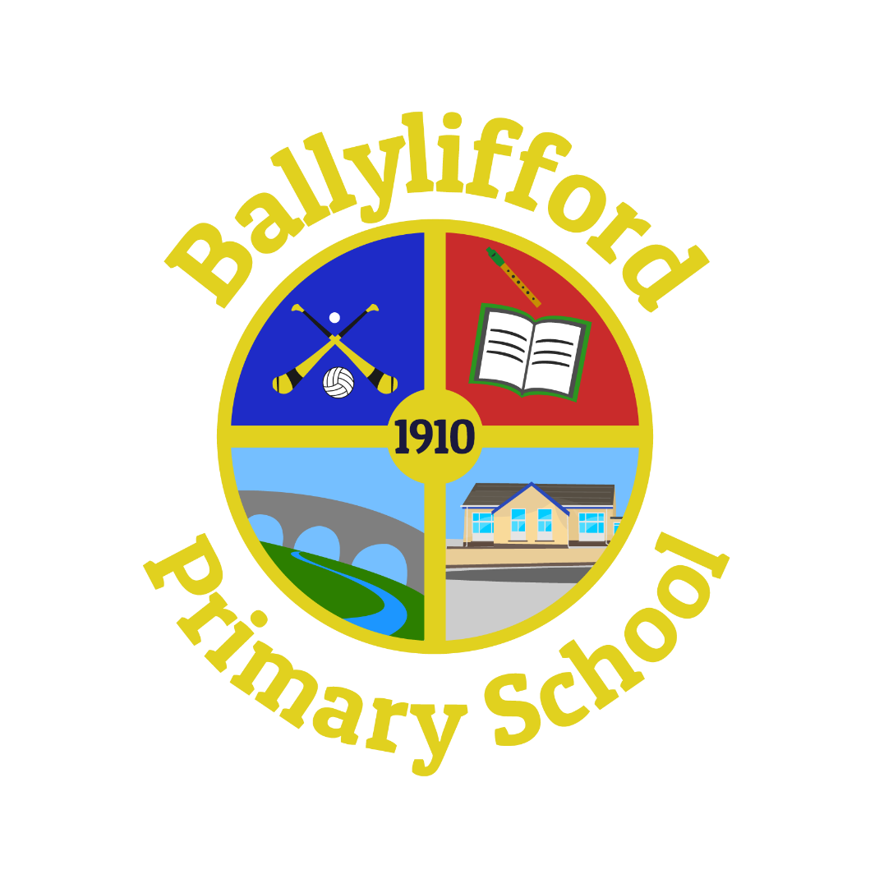

Positive Behaviour Policy

Mission Statement
We value and respect all our pupils equally. We wish through this policy to uphold everyone’s right to be safe both physically and emotionally – this requires everyone to behave in ways which keep everyone else safe. We recognise that each is unique, that each is gifted differently. Ballylifford Primary School exists to serve the Ballinderry community through the provision of a caring and effective Catholic education service which will enable pupils to make the most of their potential for academic, religious and human development. We believe that each pupil can be helped to develop further and learn more, provided each plays his/her part. We expect our pupils to work hard, to follow the school Golden Rules and School Values to co-operate fully with all staff. We expect our pupils to share responsibility within the school and to participate in its life and work, using and developing all their talents. We make it very clear to our pupils from the moment they enter our school until they leave that we will not tolerate bullying in any shape or form and that there will be sanctions for those who do bully others. We believe that there is no better way to build Family than to live Family - working hard together, sharing, caring, loving, forgiving and always being loyal.

Rationale
We in Ballylifford Primary School believe that children who have positive attitudes to school, who have high expectations of themselves and who have a strong sense of their own self-worth are most likely to take advantage of the totality of the experiences that our school offers.

Good working relationships between staff, pupils and parents are the key to effective teaching, learning and discipline.

Each member of staff aspires to have knowledge of the needs, aspirations, interests, and academic progress of each pupil.

When teachers are consistent, set clear limits, pupils will comply with rules and routines.

In preparing our approach to Positive Discipline we acknowledge the rights and responsibilities of all members of the school community.

This policy is shared with all staff, Governors, pupils and parents.

General Statement
In Ballylifford PS we provide a supportive environment which adapts to the needs of pupils of all abilities and backgrounds. We aim to organise the educational provision within the school, so that each child has the opportunity to develop physically, intellectually, socially and spiritually and so develop all talents to their full potential. We create a happy environment in which pupils can learn effectively and develop a sense of self-esteem and self-control. Our discipline policy is closely linked with and supportive of our general school policy which is based on Christian values and beliefs. We encourage parents to be active partners in the education of their children, we expect parents to accept the school’s discipline policy. We shall implement our policy fairly and consistently. Should the need for pupil suspension/expulsion arise, we shall follow the procedures laid down by CCMS/EANI.

Aims
- To maintain and build good relationships within the school between pupils, teachers, ancillary staff and parents and outside with the local community and other agencies.
- To promote behaviour that conforms to the reasonable expectations and requirements of the school and is based upon mutual respect for the needs and aspirations of all in the school and upon care for its environment.
- To create and maintain a safe and ordered school environment where Christian principles and values are practised.
- To keep agreed rules to a minimum.
- To prevent bullying behaviour of any kind to any member of the school community, by any member of the school community.
- To establish close links with external support services so that provision of appropriate support can be acquired if and when needed.
- To maintain close contact with Parents.
- To develop in pupils a sense of self-discipline and an acceptance of responsibility for their own actions.

Our Golden Rules Our School Values
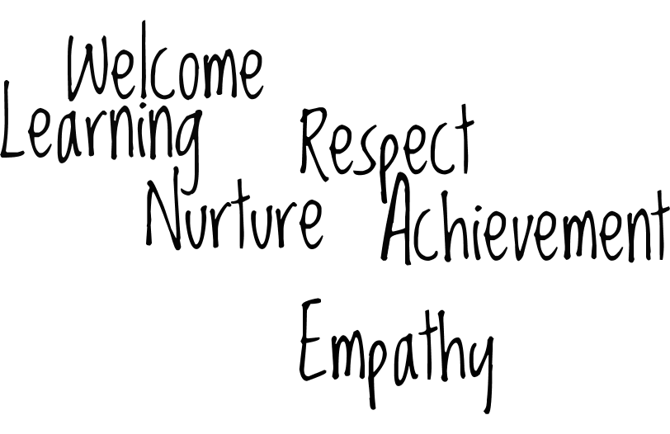
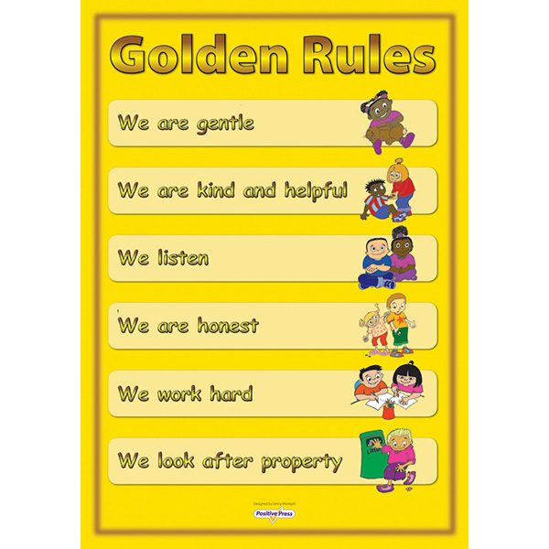

General School Rules
- Walk quietly at all times inside the school building following the Motto ‘Good Walking, No Talking’
- Put all litter in the bins and keep the school clean and tidy.
- Wear your school uniform with pride.

Classroom Rules
Each teacher will consult with his/her class to devise a set of rules appropriate for their class.

Playground Rules
Playtime is fun time.
We are good friends everyday.
We show respect to everyone in the playground.
We are kind and helpful to pupils that get hurt or upset at playtime.
We play fairly and share the games and equipment.
We treat the equipment with care, put it away and line up quietly when the bell rings.
If we have problems we tell an adult in the playground.
If we do not keep the playground rules we have Time Out Time

Canteen Rules / Lunch Time Rules
- We sit properly.
- We speak quietly.
- We use good table manners.
- We use our knife, fork and spoon properly.
- We walk carefully and quietly in the hall.
- We keep the tables clean and tidy.
- We put all rubbish in the bins.
- We line up quietly.

Expectations
- We come to school ready for work
- Be punctual at all times
- Be ready for lessons - homework done and books out, prepared to start as soon as the teacher begins
- Clear up - after lessons, break, lunch
- Respect the environment - classrooms, toilets, furniture, equipment, playground, trees, plants etc.
- Play fairly.
- Respect everyone’s rights and authority.
- Be courteous to visitors to the school.
- Co-operate with teachers at all times.

Not Allowed
The following are forbidden at Ballylifford:
- Truancy.
- Physical violence.
- Threatening behaviour.
- Bullying
- Damage to property.
- Theft of property.
- Leaving litter.
- Discrimination.

Appropriate action to deal with such behaviour will be taken immediately.

The following is essential for Good Discipline and to avoid Bullying behaviour:

Everyone in the school community should be:
- Considerate
- Courteous
- Co-operative
- Friendly
- Hardworking
- Honest
- Trusting
- Responsible
- Caring

Rewards For Good Behaviour:
Our main rewards are:
- Homework Pass
- A certificate
- Games / Toy Box
- Computer / iPad Time
- Rewards Box
- Free Time Book

Other forms of rewards are also optional.
Verbal praise from Teacher
Sent to another teacher for praise including Principal
Extra play for good behaviour
Responsibility in class and within Key Stage

Sanctions:
P1 and P2 Sanctions
- First Reminder
- Final Reminder
- No movement on reward track
- One minute time out to reflect on behaviour
- Name entered in class behaviour book
- Call to parent by class teacher

P3 – P7 Sanctions
- First Reminder
- Final Reminder
- One minute time out
- Loss of outside play at break-time / lunch-time
- 10 minute time out in classroom with work and behaviour form completed with class teacher. The form will be brought home, discussed and signed by parent / carer.
- If a child exhibits persistent poor behaviour, parents will be contacted and a meeting arranged to discuss the issues.

If pupils are asked to complete work in another classroom, each class teacher must ensure that a pupil arrives at the relevant classroom with appropriate task/tasks to be carried out. For persistent inappropriate behaviour parents will be contacted to engage their support to deal with any persistent or out of character poor behaviour. This contact will be initiated by the class teacher and followed up by the Principal if necessary A further sanction may then be imposed after consultation with parents.
In the unlikely event of continued significant bad behaviour, pupils will be excluded from School Trips or from representing the school.

Roles and Responsibilities
Rights of Pupils
- To feel safe and secure within the school environment
- To be valued equally and to be treated with respect
- To receive an appropriately planned and resourced curriculum
- To be acknowledged for effort and achievement in their class work and homework
- To be positively affirmed for abiding by the school’s disciplinary code
- To be listened to sympathetically
- To have opportunities to pursue and develop interests, talents and abilities.

Responsibilities of Pupils
- To come to school on time and to be suitably prepared
- To show respect for people and property – both inside and outside the school
- To behave in a safe and responsible manner
- To co-operate with teaching and nonteaching staff and with peers
- To ask for help when experiencing difficulties.

Rights of Non-Teaching Staff
- To be valued as members of the school community
- To be treated fairly and with respect by pupils and all members of the teaching staff
- To have adequate facilities and resources to enable staff to perform their duties effectively
- To be well informed about school rules and procedures
- To have opportunity to contribute ideas and have them taken into consideration when decisions concerning the smooth running of the school are being taken.

Responsibilities of Non-Teaching Staff
- To come on time, well-prepared for the day ahead
- To co-operate with colleagues and teaching staff
- To act in ways which aim to secure the safety of all pupils at all times
- To share with teaching staff and Senior Management any concerns they have about pupils
- To be aware of school rules and procedures
- To handle sensitive information in a confidential manner at all times
- To seek support from colleagues and Senior Management as and when required.

Rights of Parents
Parents are entitled to expect that:
- Their child will be educated in a safe and caring environment
- Their child will be provided with a broad balanced and appropriate curriculum
- They will be informed about school rules and procedures
- They will be informed about their child’s physical and emotional wellbeing
- They will be regularly informed about their child’s academic performance
- They will be involved in key decisions about their child’s education
- Their child will be taught in a well-resourced and well maintained classroom
- They will have reasonable access to school and staff.

Responsibilities of Parents
Parents have a responsibility to:
- Ensure that their child attends school regularly and punctually
- Support School staff by encouraging their child to abide by school rules
- Ensure that necessary books/equipment are brought to school
- Ensure that homework is completed satisfactorily
- Show interest in school work, meetings and functions
- Inform school of changes in home circumstances where they impact on their child’s ability to perform well at school
- Inform school of child’s special medical needs
- Encourage independence in their child

Rights of Teachers
- To work in an environment where the rights of all are respected
- To play a constructive role in policy making
- To express their views freely
- To have adequate and appropriate resources and accommodation
- To have a suitable career structure and opportunities for professional development
- To provide positive support and advice from senior colleagues and external bodies
- To feel valued

Responsibilities of Teachers
- To behave in a professional manner at all times
- To prepare and resource lessons thoroughly, taking the ability and aptitude of pupils into account
- To show interest and enthusiasm in pupils’ work and learning
- To expect high standards and to acknowledge effort and achievement
- To ensure that class work and homework are appropriately marked
- To share with parents any concerns about their child’s progress and development
- To recognise the individuality of each pupil

Staff Commitment:
- All the teachers in Ballylifford will work hard to build good discipline practices so that effective learning can take place. Staff will:
- Organise classroom space and resources carefully.
- Set tasks which enable all pupils to regularly achieve success.
- Give instructions and guidance in clear understandable language.
- Use positive rather than negative language to communicate expectations and feedback to pupils.
- Praise or reward disrupting pupils as soon as acceptable behaviour is observed.
- Be reasonable, firm, fair and positive.

Consultation & Participation

As a school we wish to regularly consult all stakeholders and ask for their participation in regularly reviewing this policy and or Anti Bullying Policy. There are a number of consultation methodologies that we can use: questionnaires, on line surveys, focus groups and/or whole school baseline audits. We will use a variety of these over time to meet our requirements.

Pupil feedback and participation will be carried out through School Pupil Council Meetings and Suggestion/Worry Box.

Signed: ___________________________________________BoG Chairperson

Signed: ________________________________________________Principal

Approved by Governors: February 2022

Next Review: February 2025

